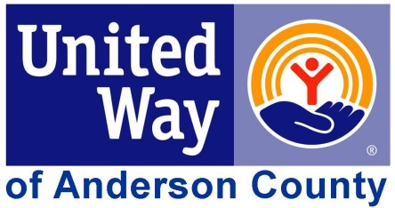

Fund Distribution Job Description
The role of a Fund Distribution Panelist is to participate in the review of 5-6 agencies and programs requesting funding from UWAC. Fund Distribution Panelists accomplish this by:

- Reviewing grant applications and all additional attachments
- Attending site visits and panel discussions
- Working as a team with other Fund Distribution Panelists to make recommendations for funding

How do participants in the Fund Distribution Program benefit?
The Fund Distribution Program offers an outstanding opportunity to gain:
- Enhanced leadership, management and communication skills
- An increased understanding of the agencies and programs in the community
- Greater knowledge of community needs and the network of service programs addressing those needs
- Feedback and insight into how dollars raised are used
Responsibilities include:
- Participation in the Fund Distribution training session
- Reviewing all materials before site visits
- Attending all site visits (one full day)
- Participating in discussions and giving feedback helping a team achieve consensus on funding recommendations

Estimated Investment of Time
- Materials review time
- One full day of site visits
- Discussion time – which may be completed on the site visit day

For more information, please contact Naomi Asher (Naomi@uwayac.org / 865-483-8431).

